Steps to get mental peace and learn improve credit rating

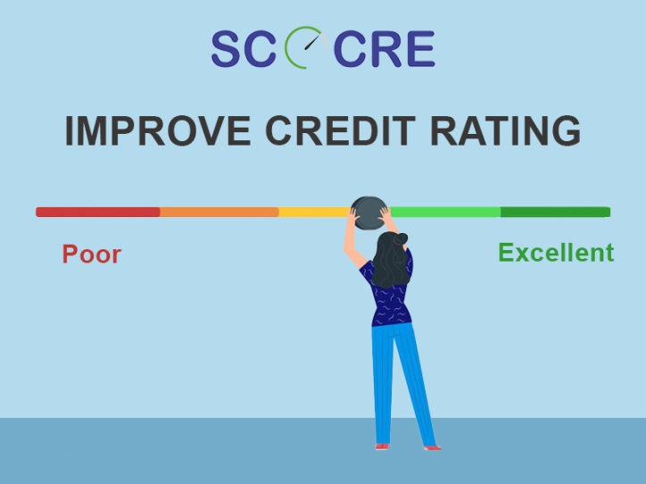

We generally hear people say, ‘Money can’t buy you happiness’. But we tell you that it helps you survive. With having enough money, you can pay your bills on time and boost your credit scores at the same time. Being unorganized or careless with your finances could steal away your mental peace as well as your credit score if you are unable to repay the loan on time.

If you are wondering how one could boost their credit rating, we tell you that you do it by staying on top of things and checking your credit report frequently. This is because, if there is a negative information and you are unaware about it, then that single piece of negative remark could adversely affect your scores. But if you happen to be in know of it, it could easily get tapped and rectified. Hence, it pays to stay vigilant.

On the other hand, a potential borrower who has a long list of lenders or a hefty amount on the back is considered to be leading a financially depressive life and must be under tremendous mental pressure. This could hamper their personal life, professional performance and also the chances of such a person committing a fraud could be high.

To avoid such unhappy situations, here are some [tips on improving your credit rating](https://scocre.com/blogs/new-credit.php).

**Have a combination of credit:** It is important to have a balance ratio of secured and unsecured credits. This [credit mix](https://scocre.com/blogs/credit-mix.php) refers to the types of accounts that make up 10% of a consumer’s credit report. The different type of credits a consumer must have in his financial portfolio includes credit cards, student loans, automobile loans, and mortgages.

**Credit utilisation:** This is crucial and not many people realize the importance of maintaining a low credit utility quotient. As a result, people often over-exceed their credit limit which should be well under 30%. Doing so improves the credit score.

**Regulate borrowing:** In general, you are eligible to apply for multiple loans, only if you successfully make repayments on your first loan for the first 3 months. This is for your convenience, but it should be opted for with extreme care. You must ensure that the amount you have borrowed does not exceed the income and you have the ability to repay the amount on time. Secondly, it is equally important to [maintain a better credit score](http://scocre.com/).

**Pay loans in time:** Make sure you pay all your bills and loans in time to avoid your credit scores from shrinking. If you are struggling to pay your current Equated Monthly Installments (EMI), then try to chalk out a plan to reduce your expenditures or speak with your banks to help you out to restructure the repayments.

We hope that our tips on keeping the credit rating brimming with happiness helps you if you have been having bad credit scores that could be damaging your future credit requirements.